****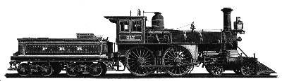

**PRR SOUTH FORK FEDERAL CREDIT UNION**

**OFFICIAL MEETING NOTICE**

**87th Annual Meeting**

**We are pleased to announce that our 87th Annual Meeting will be held at**

**The Homestead Inn at 6:00 P.M.**

**Thursday, April 20, 2023**

**ELECTION AND MEETING:**

Having met the bylaw provisions that at least one nomination has been made for each vacant position. At this time, no petition nominations having been received.

**The following Incumbents are running for 3 positions on the Board of Directors:**

**They will serve a 2-year term.**

**Timothy Troy** is retired from the Norfolk Southern Railroad, and is currently our Board President. He has served on our Board for 21 years as a Director and past Vice President.

**Michael McCall, Jr**  from C & C Smith Lumber has served on our Board since August 2022. Mike graciously accepted the appointment to fill the position held previously by Bruce Wissinger, and he is willing to continue serving on our Board.

**Kathy Churchey**  has served as our Manager 2009-2020 and as our Treasurer since 2009.

**We Thank them for their time and Appreciate their dedication in serving our members.**

**For Reservations to attend the Annual Meeting**

**\*\*\* Please call one of our offices to register by Friday, April 7, 2023 \*\*\***

**(814) 495-5150 or (814) 255-1876**

**($ 15.00 for members and $17.00 for non-members)**

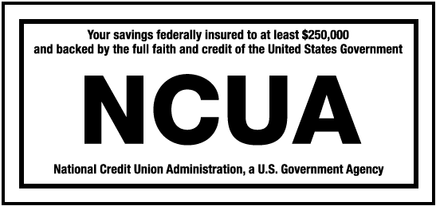 

PRR South Fork Federal Credit Union

Financial Report 12/31/2022

**ASSETS EXPENSES**

Loans Outstanding $ 13,055,776.14 Salaries $ 328,976.31

Less Allowance for Loan Loss (62,081.00) Employee Benefits 50,932.86

Cash on Hand & Checking 2,002,874.75 Travel & Conference 1,326.08

Investments 35,362,717.34 Association Dues 16,047.00

Prepaid Expenses 26,312.00 Office Occupancy 73,122.34

Fixed Assets 532,079.24 Office Operations 100,718.95

Accrued Income 28,256.12 Educational & Promo 235.45

Other Assets 566,870.95 Loan Servicing 26,783.19

**Total Assets $ 51,512,805.54** Professional Services 45,682.21

**LIABILITIES**  Provision for Loan Loss 18,374.04

Shares $ 35,807,824.91 Exam & Supervision Fees 14,381.69

IRA Accounts 3,452,698.47 Annual Meeting Expense 914.76

Share Drafts 3,822,407.16 Miscellaneous Expense 4,759.71

Club Accounts 245,058.39 Dividends to Members 178,421.34

Dividends Authorized 54,263.03 **Total Expenses $ 860,675.93**

Accounts Payable 33,306.15

Reserves & Undiv. Earnings 8,097,247.43

**Total Liabilities $ 51,512,805.54**

**INCOME DISTRIBUTION OF INCOME**

Interest collected on Loans $ 429,879.76 Operating Expense $ 682,254.59

Income from Investments 416,442.04 Dividends Payable 178,421.34

Miscellaneous Income 150,630.16 Reserves/Undiv Earnings 136,276.03

**Total Income $ 996,951.96 Total Distribution $ 996,951.96**

**\*Payoff your High Credit Card Balances with our PRR Visa Credit Card\***

**at the Great Rate of 10.90% APR**

**\*\*Be sure to watch for our VISA Balance Transfer Promotions for 2023\*\***

**Summer June 1, 2023 through August 31, 2023 at 3.99% APR**

**Fall October 1, 2023 through November 30, 2023 at 3.99% APR**

**Call our Office for more information (814) 495-5150**